Update for key stakeholders
28 October 2022

Vaccination
Members of the public are finding it difficult to find appointments on the national portal. We have availability at our clinics for December but our November clinics are filling up. We continue to look at where we can add extra capacity and will add more clinics when we can and advertise them on our website and social media.
From 1 November we will be able to share clinic availability on our website and social media. We do this weekly to help those who are looking to book their appointment.
We are hearing from our vaccination teams that, in common with other boards nationally, we are witnessing a number of DNAs (did not attend) at clinics. We will continue to issue messaging asking those unable to attend appointments to please cancel their booking so that it can be used for someone else.
As at 25 October, vaccination figures across the whole of the NHS Highland area were:
 | Over 65s % complete | Health & social care staff % complete | 5-65s at risk % complete
COVID | 63.2 | 32.1 | 14
Flu | 58.7 | 32.4 | 12.9

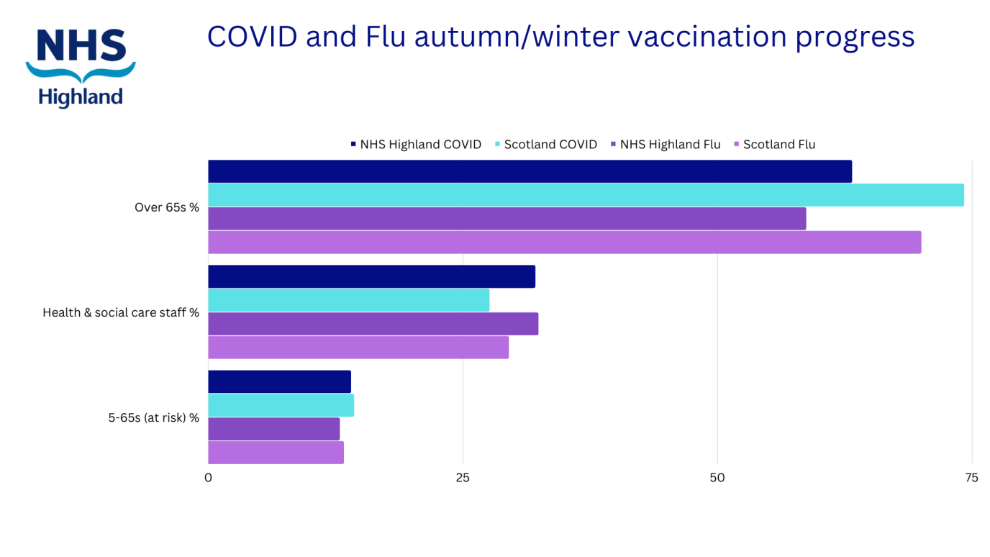
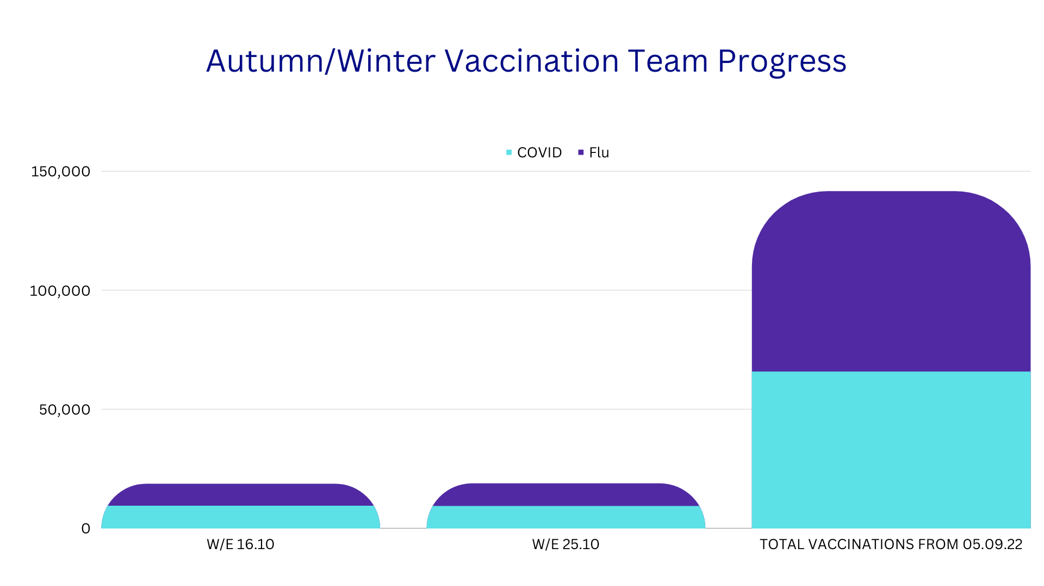

De-escalation
We are delighted to share that NHS Highland has been de-escalated on the NHS Scotland Board Performance Escalation Framework from level 3 to level 2 for Culture and Leadership. This is welcome recognition of the hard work that has gone in to securing improvement in these areas so far, and also reflects the fact that we have a clear roadmap to ongoing progress. Every organisation must always be constantly striving to improve its culture and leadership and we will continue to focus on this area.

We remain at level 3 for Finance and Mental Health while we continue to work through actions to improve performance in these areas, given the extremely challenging financial circumstances which all health boards currently face.

Chair
Our Chair, Professor Boyd Robertson, has announced he will be stepping down at the end of his four-year term on 31 March 2023. The position has been advertised on the Public Appointments Scotland website.

Feedback
If you have comments or queries please contact nhshighland.feedback@nhs.scot

